TRAFFIC MANAGEMENT

Cause of Traffic:

By normal observation we can see that traffic problem occurs only at some specific location like big highways other location donot have much traffic at same time. This is because highways have many subrouts connected. Generally these subrouts which are connected to highway donot have traffic problem but when vehicles on these subrouts add up in highway leads to traffic problem in highway.

Solution:

In current situation if there is traffic problem at some point that particular traffic signal system fails to solve traffic problem. this is because currently traffic signal does not vary with density of vehicles present at that traffic signal. In the syncronization of traffic signal we will bring contact of every traffic signal in nearby that location lets say we will syncronize all traffic signals in Pune city.

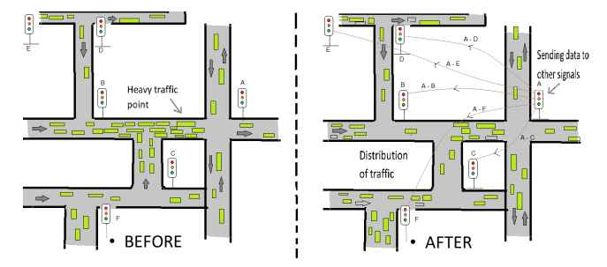

In above two pictures suppose density of vehicles at point A reached at threshold level(before section) then corresponding signal A will contact all the nearby signals(shown in After section).

Then all signals will increase there signal time with lets say 1 or 2 sec that is other signal will hold vehicles for some small extra time so that vehicles comming at point A will be decrease. Here note that we are contacting signals before the traffic problem occurs(that is density reaches to some max threshold) so ideally there will not be any traffic at all signals.

ANOLOGY – suppose that there are 10 friends, one of them having serious financial problem of 100 rs, then all 10 friends will come together and collect 100 rs by giving just 10 rs each which is not a big deal but it is for big amount for one person. That is collective effect is good. Same way if any traffic signal is in trouble then other signals will help that signal just holding extra vehicles for 1-2 sec which is not big deal to other signals but when all other traffic signals holds for 1-2 sec then it will lead to big effect in reducing traffic at particular point.

Basic idea :

Here we are increasing and decreasing the signal duration on the road in order to avoid traffic jams. This doc is in sink with the image shared. Suppose there is a main road as mentioned and is linked by 5 small roads. There is a high possibility that there is a traffic jam on the main road. The main road contains a signal. When the signal shows red, traffic strarts accumulating. To solve this issue of this unexpected traffic we have an idea. Suppose the main road signal is of 60 secs. We have sensors to keep atrack of traffic. When the traffic level reaches a threshhold value, the time of the main road signal reduces, say that it becomes 50 secs. The time reduction is of 10 secs. This time decrease is compensated by the increase in time of the signals of the roads connected to the main road. Say the time of each of the signals of the 5 roads connected to the main roads increase by 2 secs each. This increase in time of the signals depends on the traffic on these roads. Each signal is in sink with the signals before and after it on the road.

Aim :

Before implementing the idea we are checking the time for a vehicle to reach a perticular destination. After implementing the idea we are checking the time for a vehicle to reach a perticular destination. We are the comparing the two time periods and manage the optimizations.

Technology :

We are basically trying to implement this model by using GUI and some inbuilt libraries in Python programming language. Choosen language will be Python as it supports to OOP and having inbuilt libraries related to GUI and also little familiar to us.

Difficulties :

It is difficult to show and give each vehicle on the road a different path and ensure that there is no collision between the vehicles with one another and maintain path.Here we manually have to write code to ensure that there is no collision and this is not the focus of the project. The focus of the project is signal syncronization. But building responsible GUI is major problem for the project. In short in project we have to deal with1. maintain path of vehicles 2. avoid collison 3. analyase particular vehicle for comparison 4. measure density of vehicles at traffic signals. 5. statistics required for syncronization of signals. Etc...

The direction of each cameras face to the center of Junction, this means many traffic moves from old city or east side of city to new city or west side of city. From these measurements of traffic condition in Ahmedabad, the value of occupancy is lower than 25% in wide area in the city. According to our experience of the project, there is not always congested against our expectation before this project stars. The Ahmedabad traffic congestion occurs by some reason, not always crowed by traffic. This is important evidence and hints how to solve traffic congestion issues in India.

